CMPG213
Requirements Analysis
(Phase 2)

Group 6:
50344226 – Kutloano Sabalele
50763679 – Lindokuhle Kweta
45662878 – Ruan Venter
55810608 – Reinhardt van der Walt
55807593 – Sibane Ndhlela
55985866 – Wihandré Singleton
50536192 – Zizipho Zingelwa

Client: Nkanyezi Tours

Table of Contents
1. Project Plan 3
2. Definitions, Acronyms, and Abbreviations 8
3. Project Description and Scope 8
4. Functional Data, Process and Interface Requirements 9
4.1. Maintenance of Attractions 9
4.2. Maintenance of Accommodation 11
4.3. Bookings 12
4.4. Reports 14
4.5. Graphical User Interface Requirements 15
5. Non-functional requirements (PIECES Framework) 16
6. Feasibility Analysis Matrix 18
7. Use-Case Glossary & Use-Case Model Diagram 20
8. Examples of Data, Questionnaires, Fact-Finding Techniques Used 22
8.1. Interview form 22
8.2. Current system overview 22
8.3. Interview Questions and Responses 22
8.3.1. Questions to System Owner 22
8.3.2. Questions to System USER (Travel Agent) 23
9. Summary, Future & Further Planning 23

List of Figures
Figure 1: Gantt Chart 6
Figure 2: Gantt Chart (cont.) 7
Figure 3: User Interface Hierarchy 15
Figure 4: Use-Case Diagram 21

List of Tables
Table 1: Project plan 3
Table 2: Maintenance of Attractions - Create 10
Table 3: Maintenance of Attractions - Update 11
Table 4: Maintenance of Attractions - Delete 11
Table 5: Maintenance of Accommodation - Create 12
Table 6: Maintenance of Accommodation - Update 12
Table 7: Maintenance of Accommodation - Delete 13
Table 8: Booking Accommodation & Attraction 13
Table 9: Reports 15
Table 10: Non-Functional Requirements 15
Table 11: Feasibility Analysis 17
Table 12: Use-Case Glossary 19

Project Plan
Table 1: Project plan
No. | Task Name | Duration (Days) | Start Date | Finish date | Predecessors | Member  Responsible
1 | Scope Definition | 1 day | Mon 2026/03/02 | Mon 2026/03/02
1.1 | Identify baseline problems and opportunities | 1 day | Mon 2026/03/02 | Mon 2026/03/02 |  | All members
1.2 | Negotiate baseline scope | 1 day | Mon 2026/03/02 | Mon 2026/03/02 | 1.1 | All members
1.3 | Assess baseline worthiness | 1 day | Mon 2026/03/02 | Mon 2026/03/02 | 1.2 | All members
1.4 | Develop baseline schedule and budget | 1 day | Mon 2026/03/02 | Mon 2026/03/02 | 1.3 | Ruan Venter
1.5 | Communicate the project plan | 1 day | Mon 2026/03/02 | Mon 2026/03/02 | 1.4 | Ruan Venter
2 | Problem Analysis | 16 days | Mon 2026/03/02 | Mon 2026/03/23
2.1 | Understand the problem domain | 3 days | Mon 2026/03/02 | Wed 2026/03/04 | 1.5 | Ruan Venter, Reinhardt v.d Walt
2.2 | Analyse problems and opportunities | 3 days | Thu 2026/03/05 | Mon 2026/03/9 | 2.1 | All members
2.3 | Analyse business processes | 3 days | Tue 2026/03/10 | Thu 2026/03/12 | 2.2 | All members
2.4 | Establish system improvement objectives | 2 days | Fri 2026/03/13 | Mon 2026/03/16 | 2.3 | All members
2.5 | Update and refine the project | 3 days | Tue 2026/03/17 | Thu 2026/03/19 | 2.4 | All members
2.6 | Communicate findings and recommendations | 2 days | Fri 2026/03/20 | Mon 2026/03/23 | 2.5 | Ruan Venter
3 | Requirements Analysis | 14 days | Mon 2026/03/23 | Tue 2026/04/14
3.1 | Identify and express requirements | 3 days | Mon 2026/03/23 | Wed 2026/03/25 | 2.6 | All members
3.2 | Prioritise system requirements | 3 days | Thu 2026/03/26 | Mon 2026/03/30 | 3.1 | All members
3.3 | Update or refine the project plan | 8 days | Tue 2026/03/31 | Tue 2026/04/14 | 3.2 | Ruan Venter
4 | Logical Design | 13 days | Tue 2026/04/14 | Mon 2026/05/04
4.1 | Structure functional requirements | 3 days | Tue 2026/04/14 | Thu 2026/04/16 | 3.3 | Kutloano Sabalele, Lindokuhle Kweta, Wihandré Singleton
4.2 | Prototype functional requirements | 3 days | Fri 2026/04/17 | Tue 2026/04/21 | 4.1 | Reinhardt v.d Walt, Sibane Ndhlela, Zizipho Zingelwa
4.3. | Define acceptance tests | 3 days | Wed 2026/04/22 | Fri 2026/04/24 | 4.2 | Reinhardt v.d Walt, Ruan Venter
4.4 | Validate functional requirements | 4 days | Tue 2026/04/28 | Mon 2026/05/04 | 4.3 | Lindokuhle Kweta, Ruan Venter
5 | Decision Analysis | 59 days | Mon 2026/05/04 | Fri 2026/07/24
5.1 | Identify candidate solutions | 8 days | Mon 2026/05/04 | Wed 2026/05/13 | 4.4 | All members
5.2 | Analyse candidate solutions | 11 days | Thu 2026/05/14 | Thu 2026/05/28 | 5.1 | Reinhardt v.d Walt, Sibane Ndhlela, Zizipho Zingelwa, Ruan Venter
5.3 | Compare candidate solutions | 10 days | Wed 2026/05/29 | Thu 2026/06/11 | 5.2 | Kutloano Sabalele, Lindokuhle Kweta, Wihandré Singleton, Ruan Venter
5.4 | Update project plan | 10 days | Fri 2026/06/12 | Fri 2026/06/26 | 5.3 | Ruan Venter
5.5 | Recommend a system solution | 20 days | Mon 2026/06/29 | Fri 2026/07/24 | 5.4 | Ruan Venter
6 | Physical Design and Integration | 15 days | Fri 2026/07/24 | Fri 2026/08/14
6.1 | Design models | 3 days | Fri 2026/07/24 | Tue 2026/07/28 | 5.5 | All members
6.2 | Design detailed specifications | 3 days | Wed 2026/07/29 | Fri 2026/07/31 | 6.1 | Reinhardt v.d Walt, Ruan Venter
6.3 | Develop prototype | 4 days | Mon 2026/08/03 | Thu 2026/08/06 | 6.2 | All members
6.4 | Redesign business processes | 5 days | Fri 2026/08/07 | Fri 2026/08/14 | 6.3 | Ruan Venter
7 | Construction and Testing | 33 days | Fri 2026/08/14 | Wed 2026/09/30
7.1 | Develop the database | 6 days | Fri 2026/08/14 | Fri 2026/08/21 | 6.4 | Reinhardt v.d Walt
7.2 | Develop custom-built software | 11 days | Mon 2026/08/24 | Fri 2026/09/07 | 7.1 | All members
7.3 | Develop user interfaces (windows or web) | 8 days | Mon 2026/09/08 | Wed 2026/09/17 | 7.2 | Kutloano Sabalele, Lindokuhle Kweta, Wihandré Singleton
7.4 | Create a thorough test plan | 8 days | Thu 2026/09/18 | Wed 2026/09/30 | 7.3 | Sibane Ndhlela, Zizipho Zingelwa, Ruan Venter
8 | Installation and Delivery | 1 day | Wed 2026/09/30 | Wed 2026/09/30
8.1 | Conclude the project with delivery of a fully operational product | 1 day | Wed 2026/09/30 | Wed 2026/09/30 | 7.4 | All members
8.2 | Review document quality and provide an operational manual | 1 day | Wed 2026/09/30 | Wed 2026/09/30 | 8.1 | Ruan Venter

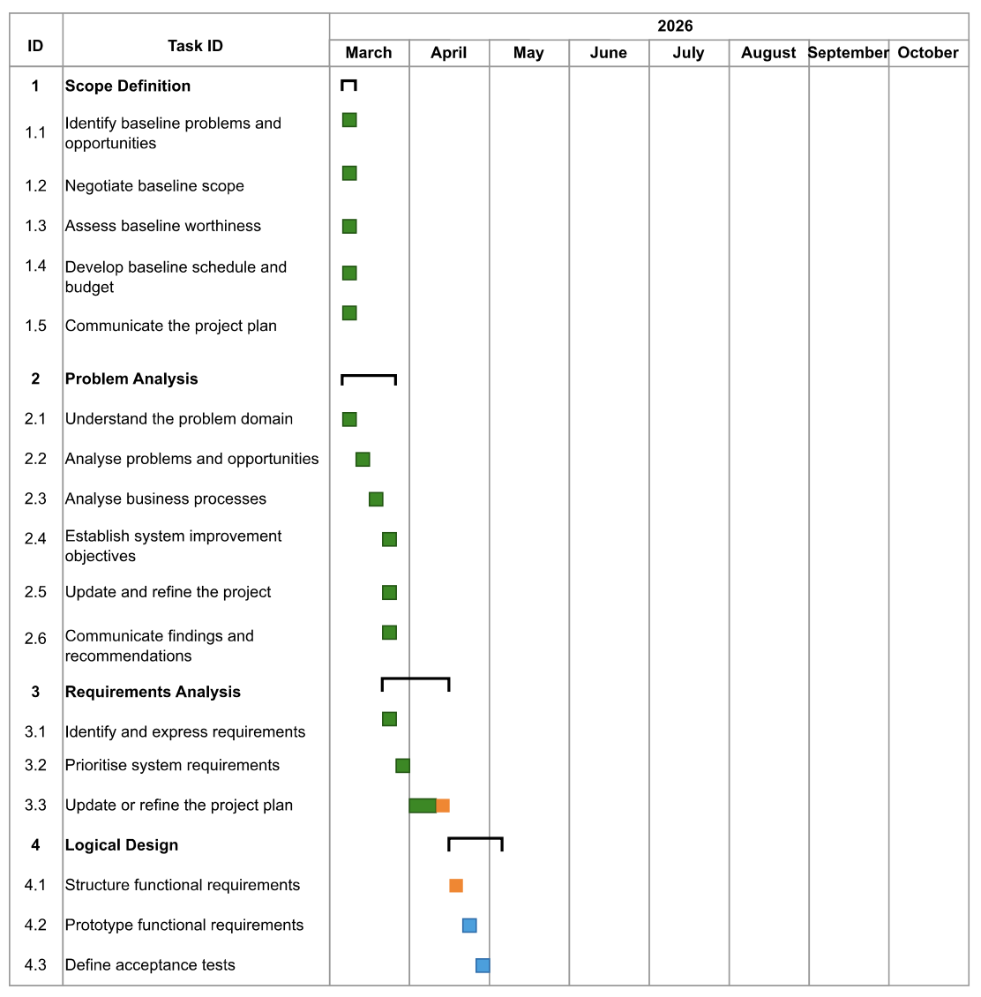
Project Plan Gantt Chart:
Figure 1: Gantt Chart

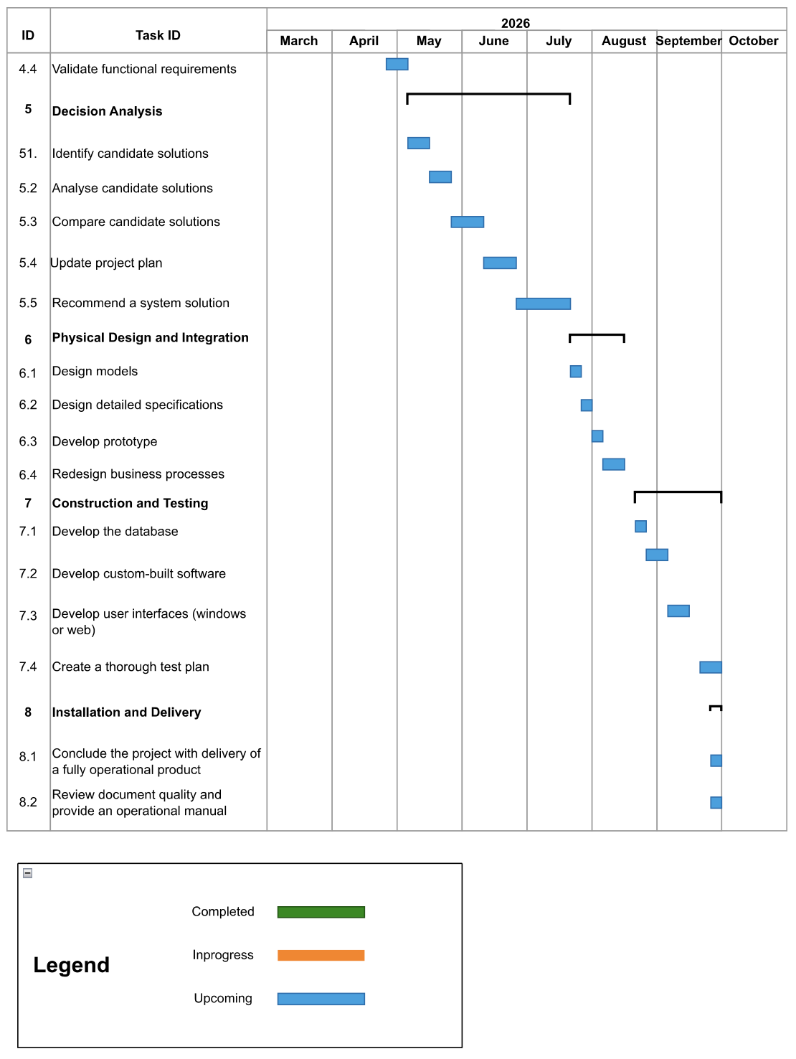
Figure 2: Gantt Chart (cont.)

Definitions, Acronyms, and Abbreviations
Acronyms:
- PIECES: Method used in system analysis to identify problems and opportunities. Performance, Information, Economics, Control, Efficiency, and Services.
- FAST: Framework for the Application of System Thinking is a system analysis methodology that promotes a structed approached.
Definitions:
- Gantt Chart: A bar chart depicting project tasks on a timeline utilising a calendar.
- Trip: A journey to and back from a place for pleasure or business which clients book with Nkanyezi Travel.
- Management role: The overlapping use cases the Administrator and Supervisor has.
- Travel Agent: Employees of Nkanyezi Tours involved with clients

Project Description and Scope
The main objective of this project is to create a computerised solution for Nkanyezi Travel is to reduce the number of telephonic inquiries received from clients to relieve pressure off of travel agents to attend to their other responsibilities. Clients will have a full scope of the accommodation, activities, transport options and prices available without needing to engage with an agent. Agents will create notes related to client’s trip on the system so that other agents know what to do if the agent is absent.
In addition, we will secure data and restrict unwanted access.
The FAST methodology will be followed throughout the development of this project.

The system must have the following functional requirements:
- Maintain attractions
- Maintain accommodation
- Maintain transport
- Manage trip expenses
- Manage itineraries
  - Client self-help portal to view, add, or remove activities, accommodation, or transport options.
- Export data to PDF and Excel
- Generate reports
  - Examples: Revenue analysis, seasonal trends, tourism hotspots.

The system must have the following non-functional requirements:
- User roles and access control
The system will be used by 4 types of users with different access and specified functionality:
  - Administrator
  - Supervisor
  - Travel Agent
  - Client
- Secure login
- Database capacity (1000+ trips annually)
- 2.5-second page loading
- 24/7 web browser accessibility

Functional Data, Process and Interface Requirements

Maintenance of Attractions
Table 2: Maintenance of Attractions - Create
Maintenance of Attractions
Ctreate new attraction
Input Data | Processing | Output
• AttractionId  • Name  • Category (selected from list)  • Address  • City  • Province (selected from list)  • Description  • Rate  • Quantity  • UOM (Unit of Measure)  • DurationMinutes  • OperatingTimes  • BestOperatingSeason | • Validate all required fields are completed before saving.  • Validate that the AttractionId does not already exist in the Attractions table.  • Validate that Rate and Quantity are numeric and greater than zero.  • Validate that OperatingTimes and BestOperatingSeason are in an accepted format.  • After the user clicks the Save button, the new attraction record is inserted into the Attractions database table. | • Warning message displayed if any required field is left empty.  • Warning message displayed if the AttractionId already exists.  • Warning message displayed if Rate or Quantity contain invalid values.  • Success message displayed to confirm the attraction has been successfully added.

Table 3: Maintenance of Attractions - Update
Maintenance of Attractions
Updating an attraction
Input Data | Processing | Output
• AttractionId (used to locate the record)  • Updated fields as needed: Name, Category, Address, City, Province, Description, Rate, Quantity, UOM, DurationMinutes, OperatingTimes, BestOperatingSeason | • Display the current details of the selected attraction.  • Allow the user to modify any of the editable fields.  • Validate that all required fields remain completed.  • Validate that Rate and Quantity remain numeric and greater than zero.  • After the user clicks the Save button, the updated record is written to the Attractions database table. | • Warning message displayed if the AttractionId is not found.  • Warning message displayed if any required field is cleared or contains an invalid value.  • Success message displayed to confirm the attraction has been successfully updated.

Table 4: Maintenance of Attractions - Delete
Maintenance of Attractions
Deleting an attraction
Input Data | Processing | Output
• AttractionId (used to identify the record to be deleted) | • Display the details of the selected attraction for the user to review.  • Prompt the user with a confirmation dialog before proceeding.  • After the user confirms, the selected attraction record is removed from the Attractions database table. | • Warning message displayed if the AttractionId is not found.  • Confirmation prompt displayed before deletion is executed.  • Success message displayed to confirm the attraction has been successfully deleted.

Maintenance of Accommodation
Table 5: Maintenance of Accommodation - Create
Maintenance of Accommodation
Create new accommodation
Input Data | Processing | Output
• AccommodationId  • Name  • Description  • Type  • Address  • City  • Province (selected from list)  • StarRating  • PricePerNight  • Capacity  • Rooms[] (Room number, beds, size, bathroom, available)  • Amenities | • Validate all required fields are completed before saving.  • Validate that the AccommodationId does not already exist in the Accommodation table.  • Validate that PricePerNight, StarRating, and Capacity are numeric and greater than zero.  • Validate that the Rooms array contains at least one valid room entry.  • After the user clicks the Save button, the new accommodation record is inserted into the Accommodation database table. | • Warning message displayed if any required field is left empty.  • Warning message displayed if the AccommodationId already exists.  • Warning message displayed if PricePerNight, StarRating, or Capacity contain invalid values.  • Success message displayed to confirm the accommodation has been successfully added.

Table 6: Maintenance of Accommodation - Update
Maintenance of Accommodation
Updating accommodation
Input Data | Processing | Output
• AccommodationId (used to locate the record)  • Updated fields as needed: Name, Description, Type, Address, City, Province, StarRating, PricePerNight, Capacity, Rooms[], Amenities | • Display the current details of the selected accommodation.  • Allow the user to modify any of the editable fields.  • Validate that all required fields remain completed and that numeric fields contain valid values.  • After the user clicks the Save button, the updated record is written to the Accommodation database table. | • Warning message displayed if the AccommodationId is not found.  • Warning message displayed if any required field is cleared or contains an invalid value.  • Success message displayed to confirm the accommodation has been successfully updated.

Table 7: Maintenance of Accommodation - Delete
Maintenance of Accommodation
Deleting accommodation
Input Data | Processing | Output
• AccommodationId (used to identify the record to be deleted) | • Display the details of the selected accommodation for the user to review.  • Prompt the user with a confirmation dialog before proceeding.  • After the user confirms, the selected accommodation record is removed from the Accommodation database table. | • Warning message displayed if the AccommodationId is not found.  • Confirmation prompt displayed before deletion is executed.  • Success message displayed to confirm the accommodation has been successfully deleted.

Bookings
Table 8: Booking Accommodation & Attraction
 | Booking an Accommodation
 | Input Data | Processing | Output
 | • AccommodationId  • ClientId  • Check-in date  • Check-out date  • Number of rooms required  • Preferred room type | • Display the selected accommodation with available rooms and pricing.  • Validate that the selected check-in and check-out dates do not conflict with existing bookings.  • Validate that the number of rooms requested does not exceed available capacity.  • Calculate the total cost based on PricePerNight and the number of nights.  • Validate that the total cost does not exceed the client's estimated budget.  • After the user clicks the Save button, the booking record is inserted into the Bookings database table. | • Warning message displayed if the selected accommodation is fully booked for the requested dates.  • Warning message displayed if the booking cost exceeds the client's estimated budget.  • Warning message displayed if required fields are incomplete.  • Success message displayed to confirm the accommodation has been successfully booked.  • Booking summary displayed showing accommodation name, dates, rooms, and total cost.
Booking an Attraction
Input Data |  | Processing | Output
• AttractionId  • ClientId  • Booking date  • Quantity (number of tickets or participants)  • Preferred operating time slot |  | • Display the selected attraction with available time slots, rates, and duration.  • Validate that the selected date falls within the attraction's BestOperatingSeason and OperatingTimes.  • Validate that the requested quantity does not exceed available capacity.  • Calculate the total cost based on Rate and Quantity.  • Validate that the total cost does not exceed the client's estimated budget.  • After the user clicks the Save button, the booking record is inserted into the Bookings database table. | • Warning message displayed if the attraction is unavailable on the selected date or time slot.  • Warning message displayed if the requested quantity exceeds available capacity.  • Warning message displayed if the booking cost exceeds the client's estimated budget.  • Success message displayed to confirm the attraction has been successfully booked.  • Booking summary displayed showing attraction name, date, quantity, and total cost.

Reports
Table 9: Reports
Report
Input Data | Processing | Output
• Report type (selected from a list of available report categories)  • Date range or filter criteria (where applicable) | • The user selects the desired report type and clicks the Continue button.  • According to the report type selected, the corresponding SQL query is executed against the database.  • The retrieved data is formatted and structured for display.  • Where applicable, totals, averages, and aggregates are calculated. | • User is notified that the report is available.  • Formatted report information is displayed on screen.  • Report data can be exported to PDF or printed as per the scope requirement for data export.

Graphical User Interface Requirements

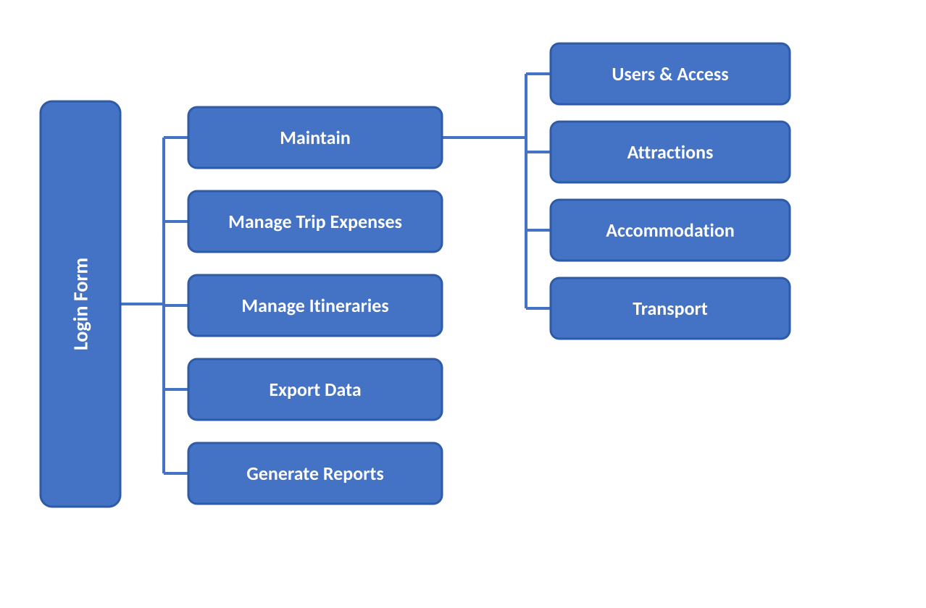
Figure 3: User Interface Hierarchy
The diagram above illustrates the proposed graphical user interface hierarchy for the Nkanyezi Tours information system. All users must authenticate via the Login Form before accessing any module. The system is organised into five functional areas:
Maintain – Provides master data management for four entities: Users & Access, Attractions, Accommodation, and Transport. Each entity supports add, update, and delete operations.
Manage Trip Expenses – Enables travel agents and clients to capture, track and update all client trip expenditure.
Manage Itineraries – Allows travel agents and clients to compile and manage complete trip itineraries tailored to client preferences.
Export Data – Supports exporting of itineraries and trip data to PDF for offline client access in areas with limited connectivity.
Generate Reports – Provides management with automated reporting on revenue, seasonal trends, employee performance, and operational efficiency.

Non-functional requirements (PIECES Framework)
Table 10: Non-Functional Requirements
Requirements | PIECES Categories
- Queries on database should not take longer than 2.5 seconds  - This to promote fast, efficient working site  - Ensure that the site is available when needed | - Performance
- The SQL Database will be holding data for approximately about 46 attractions and over 50 accommodations nation-wide  - The database will take over 1000 queries annually | - Information and Data  - Performance
- The higher the quantity demanded, the more positive the profit margin of the product  - Meaning good marketing strategies will be needed to ensure that stakeholders are also seeking the help of our site  - Ensuring that our services are affordable to customers and that stakeholders are happy with the service we provide  - Increasing the number of users will also increase our profit margin | - Economics  - Control Cost  - Increase Profits
- Login details will be kept in our password database verify using an MFA (Optional)  - Registered account only accessible with the right login details  - Internal Control is important in an entity as it ensures the system’s data is controlled by only authorised personnels  - The Administrator will have a access to all functionality except fixing of payments, they can only view the account to verify payments  - Customers will have an only have access to specified functionality | - Control and Security
- Provide an eye safe site  - Ensure the site customer friendly and easy to understand | - Service to stakeholders
- Detail contacts of accommodations, rental cars companies, etc.  - For more information on how to use the app, email address of the site admin will be available for only use of certain hours in a week | - Efficiency of people, processes

Feasibility Analysis Matrix
Table 11: Feasibility Analysis
Description | Wt | Candidate 1: As is | Candidate 2: Bought software | Candidate 3: Custom built software.
Technical feasibility | 20 | This candidate can be used, but it cannot be changed by the project team. Which means it is ineffective.  Score: 20 | The software is easy to install but customizing it for specific Nkanyezi modules (like car rental maintenance) may be difficult as the team is unfamiliar with the vendor's proprietary code.  Score: 40 | The project team is highly proficient in the chosen programming language and database software. They have the required knowledge to design the custom client portal and maintenance modules  Score: 80
Operational feasibility | 10 | This candidate can be used but it is inefficient and can lead to data loss. This system relies on pen and paper and remembering bookings this can lead to misremembrance of bookings or rentals. And it makes finding previous bookings hard.  Score: 40 | This system will be more effective than the current one as it is database backed and will lead to less loss of data. It will be hard for system users and admin to use as it is a new system that is not tailor made for the company which means it may not have all the needed functionality, and it will need a work around.  Score: 75 | This candidate will fulfil all the user’s needs. There will minimal data loss and booking are made automatically this will be the most efficient solution to the problem at hand. It will have specific features tailor made for the company and it will boost the efficiency in which things are done and thus it is the best option.  Score: 90
Risk feasibility | 20 | Risk of data loss due to "personal notebooks" being the primary record. Reporting is slow and manual, leading to a high probability of management making decisions on outdated facts  Score: 15 | Low risk of data loss, but a moderate risk that the software won't fully integrate with local South African car rental and bus shuttle providers.  Score: 50 | The project team has a substantial amount of experience in the programming language and software used to create the system. The failure to implement the system successfully is low.  Score: 90
Economic feasibility | 20 | The Economic impact for the business as it is could be that data and bookings are missed which can lead to economic loss, but no extra money must be paid for this system.  Score: 67 | Bought systems can be expensive to buy and it may not have all the usability that is needed. But it would fix the issue of payments or data being lost when noted down manually.  Score: 50 | Custom built systems will be the best solution to the problem, but it will also be the most expensive to buy.  Score: 45
Schedule feasibility | 10 | No changes are required, meaning the system is operational immediately, albeit inefficiently  Score: 20 | It cannot be guaranteed that all custom requirements will be completed by the 30 September 2026 deadline. Additional time will be required to complete the system.  Score: 50 | By utilizing reverse scheduling and resource levelling, the team is confident the system will be fully developed and tested before the September 2026 deadline  Score: 80
Cultural feasibility | 10 | The system users do not agree with this candidate and shows resistance towards it  Score: 0 | The users show minimal resistance towards this candidate as it comes from a trusted source built by professionals. Although it would not have the finer functionality required to run the operation as smooth as possible.  Score: 70 | The system users show small amounts of resistance towards this candidate as if not implemented well it can make running the business inefficient and tedious.  Score: 60
Legal feasibility | 10 | There are no signs of legal issues.  Score: 100 | Legal issues could arise if data breaches occur.  Score: 80 | Legal issues could arise if data breaches occur.  Score: 80
Weighted feasibility | 100% | 36.4% | 55.5% | 74%

Compliance Acts for software development ensure data security, privacy, and safety, covering regulations like POPIA, GDPR, HIPAA, and the new EU Cyber Resilience Act (CRA). Key compliance requires embedding privacy-by-design, encryption, and regular audits into the SDLC to avoid fines, with a focus on protecting user data from inception.
Examples:
- Data Protection & Privacy: POPIA
- Cybersecurity & Infrastructure: Cybercrimes Act (2020)
- Consumer Protection: CPA

Standard formula:
Weighted Score = (Score × Weight) / 100

Although the custom-built system has a higher initial cost, its superior technical alignment, operational efficiency, and lower long-term risk make it the most feasible solution overall.

Use-Case Glossary & Use-Case Model Diagram
Table 12: Use-Case Glossary
Use Case Name | Use Case Description | Participating  Actors and Roles
Register to system | The event where a user register to the system by creating username and password. | Client
Log into system | The event where a user get access to the system by providing a username and password. | Administrator, Client, Supervisor, Travel agent
Maintain system user and access (CRUD) | The event where new users are added, existing user details are updated, or user access rights are modified/remove | Administrator
Maintain attractions | The event where new attractions are added, existing attraction details are updated, or attractions are removed from the system. | Administrator, Supervisor
Maintain accommodation | The event where new accommodation options are added, existing accommodation details are updated, or accommodations are removed from the system. | Administrator, Supervisor
Maintain transport | The event where new transport options are added, existing transport details are updated, or transport records are removed from the system. | Administrator, Supervisor, Travel agent
Manage trip expenses | The event where trip-related expenses are recorded, updated, or removed from the system. | Administrator, Client, Supervisor, Travel agent
Manage itineraries | The event where itineraries are created, updated, or removed to organize trips. | Administrator, Client, Supervisor, Travel agent
Export data | The event where system data is exported to external formats for backup or reporting purposes. | Administrator, Supervisor, Travel agent
Generate reports | The event where reports are requested from the system, viewed on screen, or printed as hard copies or sent to user emails. | Administrator, Supervisor

Use-Case Diagram:

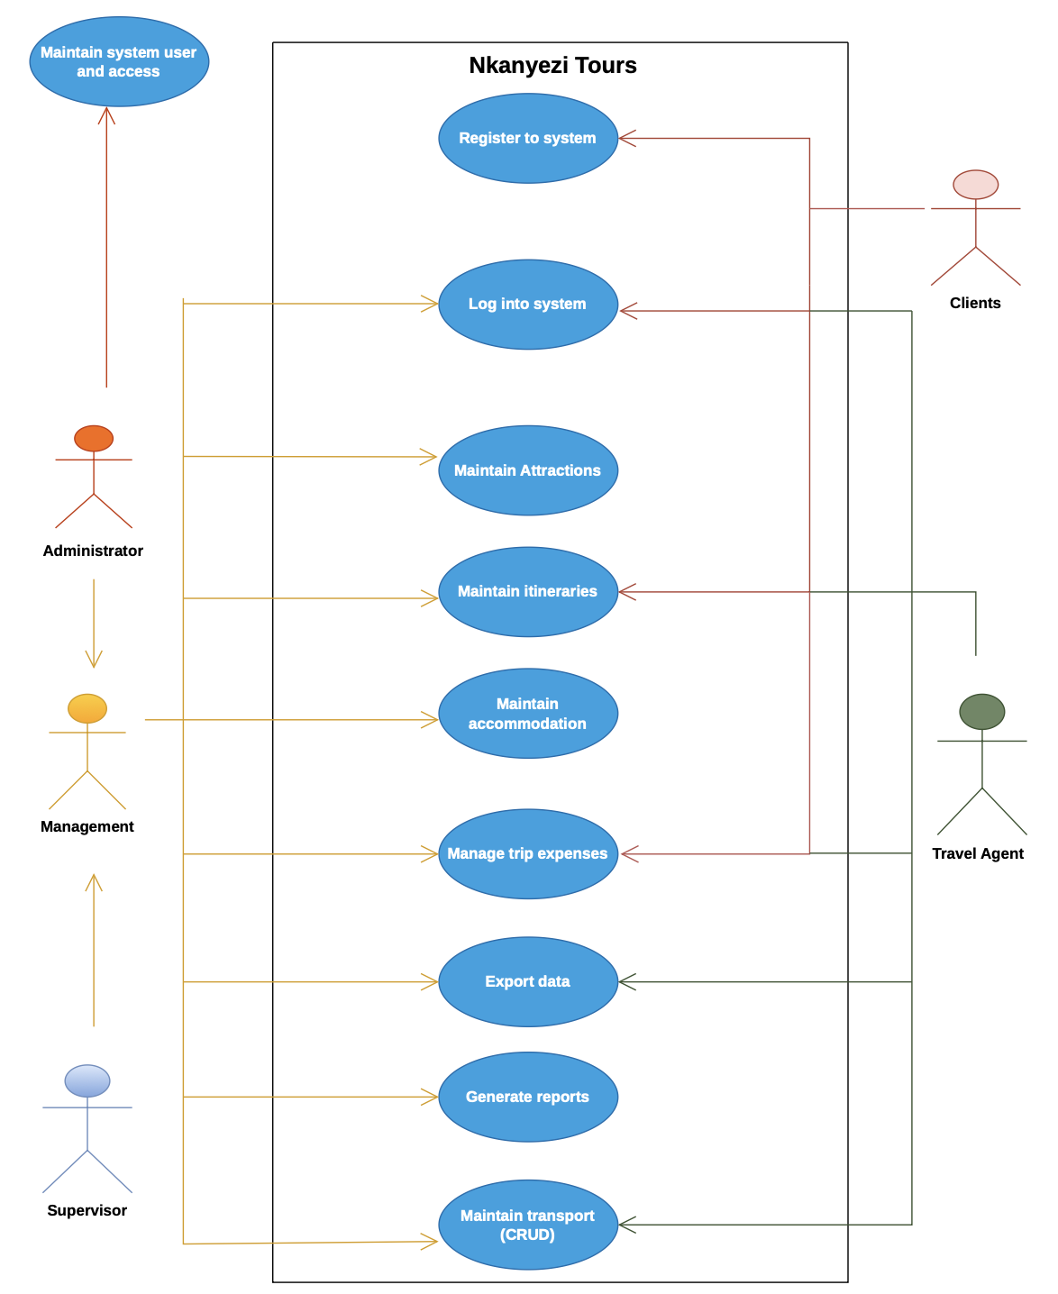
Figure 4: Use-Case Diagram
Note: Clients add attractions, accommodation and transport options to their trip by using trip expenses itineraries.

Examples of Data, Questionnaires, Fact-Finding Techniques Used

Interview form
Item | System scope interview 2 March 2026
Interview Date
Location | Online
Interviewer | Lindo Kweta (System Analyst)
Interviewee 1 | Vincent Govender (Owner)
Interviewee 2 | Travis Hale (Travel agent)
Method | Structured interview

Current system overview
The current system is manual, relying on:
- Pen and paper for booking records.
- Personal notebooks for tracking rentals
- Manual searching for past records.
Identified Problems:
- High risk of data loss
- Difficulty in retrieving past bookings.
- Time-consuming processes
- Errors in booking management
- Lack of reporting and analytics

Interview Questions and Responses

Questions to System Owner
Q1: What are the main challenges with the current system?
- Difficulty tracking bookings.
- Loss of important data
- Inefficient reporting
Q2: What features would you like in the new system?
- Centralised database
- Automated booking system
- Reporting and analytics
- Payment tracking
Q3: What is your budget and timeline?
- Budget: R1,935,360.00
- Deadline: September 2026

Questions to System USER (Travel Agent)
Q1: What problems do you face daily?
- Difficulty remembering bookings.
- Manual record-keeping is slow.
- Hard to find customer history.
Q2: What features would improve your work?
- Easy booking interface
- Search functionality
- Notifications/reminders
Q3: Are you comfortable using a new system?
- Yes, but training will be required.

Summary, Future & Further Planning
Summary:
The interview revealed that the current manual system is inefficient and prone to errors. Both the system owner and users strongly support the implementation of a digital solution that improves efficiency, accuracy, and data management.
This document covered the requirements of Nkanyezi Travel’s information system project.

Conclusion:
Based on the interview, the proposed system should be a custom-built software solution that meets the organisation’s specific needs.

Phase concluded: Requirements Analysis
After requirements acceptance: Logical design phase to be completed by 4 May 2026.

